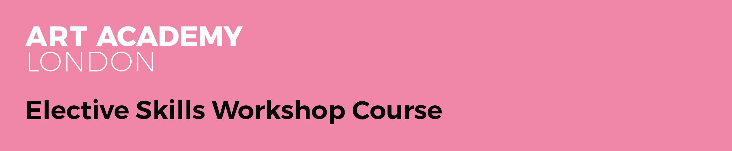

Course Title | Introduction to Oil Painting
Tutor | Nicholas McLeod  (Gail Seres Woolfson covering first class on Tuesday 20th September 2022)
Studio Session Dates | Tuesdays: 20th September - 29th November 2022  Reading week 24th - 28th October 2022
Session Times | 10:30AM - 4:30PM
Course Code | E2201P001
Studio | Studio 2
Cost | £575.00

Course overview
This course is suitable for those who have little or no experience with oils and wish to improve their technical skills with students gaining a basic understanding of how to work in oil paint and the practicalities of using oil painting materials. You will gain the confidence to work in oils and your tutor will help you start to develop a technical skill that can be used successfully to convey your visual ideas.
Your tutor will support you fully throughout the course in both group sessions and one-to-one support, providing very regular feedback, critique and constructive advice.

Learning Outcomes

Students will be able to:

Understand the purpose of various painting equipment and use it to create oil paintings.
Understand the properties of oil paint and apply it to achieve a variety of effects.
Understand the properties of different surfaces/ substrates for oil painting and utilise them to different effects.
Develop an understanding of composition, tone and colour.
Mix colours from both limited and full palettes.
Paint a simple still life in tone and in colour in oil.
Create oil paintings working from direct observation, applying measurement techniques to ensure correct proportions and perspective.
Paint the figure in tone and in colour.
Apply safe-working practices at all times.

What Level is the course and do I need any particular skills?

This course is suitable for all levels; some experience of drawing would be an advantage.

About your tutor

Nicholas McLeod graduated with an MA in painting from the Slade School of Fine Art in 2016. He has won the Threadneedle Prize Visitors Choice award and his work has been selected for numerous exhibitions across London. Nicholas has also had his work included in various publications including, A Brush With The Real: Contemporary Figurative Painting (Laurence King Publishing) and Imagine Architecture (Gestalten, Berlin)
https://www.nicholasmcleod.com

Weekly breakdown

Below is a weekly breakdown of what will be covered. Please bear in mind that these sessions will move with the pace of the group, so a degree of flexibility of what will be covered on which day will be employed.

Wk | Date | Topic/Activity | Location, Tutor & Model | What to bring
1 | 20th Sept | Health & Safety briefing  Introduction to materials and developing tonal awareness  Tonal still life  Starting with an introduction by your tutor, you will work with a few simple objects, and explore composition, looking at the relationships between the objects and how light and shadows affect composition. You will then paint a simple still life from observation in tone, using these objects. | Nicholas McLeod  Studio 2  No model | Ultramarine blue, burnt umber & titanium white oil paint,  Canvas board around 10 x 12 inches,  A3 oil painting paper (optional),  Painting equipment (see requirements below)
2 | 27th Sept | Colour mixing  After a brief introduction to the field of colour theory you will learn the practicalities of how to mix colours through a series of exercises. You will then copy a simple image, trying to match the colours. | Nicholas McLeod  Studio 2  No model | Full range of oil colours, Cadmium Red, Cadmium Yellow, Lemon Yellow, White, Burnt Umber, French Ultramarine, Coeruleum Blue, Alizarin Crimson  A3 oil painting paper (optional),  Canvas board around 10 x 12 inches,  Painting equipment
3 | 4th October | Textural Paint Application  An introduction to painting mediums will be given at the beginning of the class.  Using a still life you will be encouraged to think about mark making and the application of paint, experimenting with tools and mediums.  We will also look at preparing alternative surfaces for next week’s session. | Nicholas McLeod  Studio 2  No model | Full range of oil colours, Cadmium Red, Cadmium Yellow, Lemon Yellow, White, Burnt Umber, French Ultramarine, Coeruleum Blue, Alizarin Crimson  A3 oil painting paper (optional),  Canvas board around 10 x 12 inches,  Painting equipment
4 | 11th Oct | Oil Sketching  Quick oil sketching and developing a fluency of style. You will paint up to six quick oil sketches to help you understand how to paint more instinctively and with confidence. This will also be an opportunity to explore alternative surfaces in painting. | Nicholas McLeod  Studio 2  No model | 6 x canvases, canvas boards/primed MDF or cardboard 10 x 12 inches  or A3 oil painting paper,  Oil paints & painting equipment
5 | 18th Oct | Life model in tone  Figure painting. For the next three weeks, you will be introduced to figure painting. Starting with drawing, we will study proportion, depth & form. You will then paint a brief tonal study of the model. | Nicholas McLeod  Studio 2  Model Yes | Oil paints and painting equipment  Canvas or canvas board  Drawing equipment
Reading Week

6 | 1st Nov | Life Model in colour week 1  Painting the figure in colour. Starting a two week pose, we will learn how to mix flesh colours and think about composition when working from the figure. | Nicholas McLeod  Studio 2  Model Yes 1 x 2 | Oil paints and painting equipment  Canvas or canvas board  Drawing equipment
7 | 8th Nov | Life Model in colour week 2  Completing your painting. How to assess and finish work. | Nicholas McLeod  Studio 2  Model Yes 2 x 2 | Oil paints and painting equipment  Canvas or canvas board of a larger scale  Drawing equipment
8 | 15th Nov | Personal Project week 1  You will now make work from your own subject matter, either a themed still life featuring your own objects, or working from a photograph. Looking at relevant artists, students will consider working around a subject or idea, embarking on a two-week composition applying skills acquired. | Nicholas McLeod  Studio 2  No model | Oil paints and painting equipment  Canvas or canvas board  Drawing equipment  Still life objects (to be advised by tutor)
9 | 22nd Nov | Personal Project week 2  Continuing with your project from the previous week. | Nicholas McLeod  Studio 2  No model | Oil paints and painting equipment  Canvas or canvas board  Drawing equipment  Still life objects (to be advised by tutor)
10 | 29th Nov | Personal Project week 3  Completing painting from the previous week. Final critique of work made during the course. | Nicholas McLeod  Studio 2  No model | Oil paints and painting equipment

Preparation Requirements & Additional Costs
YOU MUST BRING YOUR OWN MATERIALS.

The Academy is a white spirit and turpentine free environment and only odourless spirits, such as Zest-it or Sansodor, are permitted on the premises. Students must provide their own spirits, which can be recycled for longevity.

We request that you bring 2 small jars (one with a lid, one without) to hold your spirit, and a few cloth rags for brush cleaning (such as an old cotton t-shirt).

Below is a list of what is currently required for the course. Please also check the ‘what to bring’ sections above. Your tutor will advise if further materials or equipment are required as the course progresses.

- Drawing equipment (inc. 2B & 4B pencils), rubber, charcoal, putty rubber
- A3 pad oil painting paper (useful but not essential)
- Brushes – Hogs hair brushes in a range of sizes, (such as Filbert no. 7 & 10, round no. 4, flats), option of additional range of synthetic brushes
- Palette knife
- Only odorless spirits, Sansodor or Zest-it (the Academy is a white spirit free environment)
- Liquin Original
- Jam jar x 2 with lids
- Palette, tear-off or wooden, ideally A3 size
- Oil colours: Cadmium Red, Alizarin Crimson, French Ultramarine Blue, Cerulean Blue*, Cadmium Yellow, Burnt Umber, Titanium White (optional extras: Viridian Green, Phthalo blue, Lemon Yellow, Yellow Ochre, Raw Umber, Purple, Black)
* If you buy the Art Academy Oil Painting Pack, please be aware Cerulean Blue is required in addition to the pack.
- Apron or old shirt
- Old rags
- Baby wipes
- Surfaces (specified each week, note that sizes are flexible)

If you do not have your own painting materials, there is an option to order an Oil Painting Pack at the time of booking which will be available when you arrive for your first class.

An Oil Painting Pack (£75.00) *contains:
A set of bristle brushes, both flat and round, suitable for either oils or acrylics
One tear-off palette (9”x12”)
One palette knife
One bottle Zest-it (250ml)
Two 8″x10″ canvas boards
Three 10″x14″ canvas boards
Six Daler Rowney oil tubes including: titanium white, cadmium yellow, alizarin crimson, cadmium red, French ultramarine and burnt umber

*subject to availability

Certain materials can also be purchased from the Academy shop during shop hours. Please check in advance of your class if the item you require is available, as the Academy may not have this in stock.

Resources & Further Reading

Please note reading lists are suggested, not required.

Author | Year | Title | Publisher | Location
Cuthbert, R. | 2001 | Oil Painter's Pocket Palette | North Light Books | Cincinnati
Hornung, D. | 2012 | Colour - a workshop for artists and designers | Laurence King Publishing | London

Other useful resources (websites, galleries etc)
Tate Gallery Website https://www.tate.org.uk/art

National Gallery London https://www.nationalgallery.org.uk

Jackson’s Art Supplies https://www.jacksonsart.com

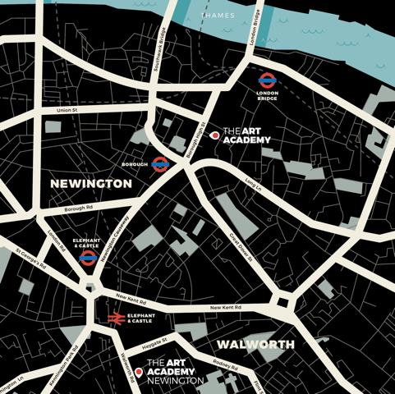

Who can I contact for further information?
General information and advice on courses at Art Academy London is available from the main office, open Monday to Friday 09:00 – 17:00 during term time.
Tel: +44 (0) 20 7407 6969 or email our Reception, Imogen Patel: imogen@artacademy.org.uk

Location
The Art Academy is conveniently located minutes away from London Bridge (Northern and Jubilee lines, National Rail services) and Borough (Northern line) underground stations - follow signs for Borough High Street to exit. Please click here for a map.

Just moments walk from the Thames, Art Academy London is also ideally located for access to:

White Cube
Tate Modern
Jerwood Gallery

If you would like to make the most of the area a member of the team will be happy to advise you on areas of interest locally.

Refreshments & Facilities

All students have access to the common room located in the Barn, on the ground floor of the Mermaid Court building. Here you will have use of a fridge, kettle, microwave and eating area.

There is a wealth of supermarkets, shops and cafes in the area as well as the world-famous Borough Food Market, five minutes walk away.

Disabled Access
We make every effort to accommodate students’ access requirements, but if you have mobility issues, please speak to a member of the Academy team before your course starts.

Further Details

- You will need to have paid in full for your class before the first session of your class, your place is not guaranteed until we have received payment.

- If you purchased a materials pack online this will be given to you on the first session of your course upon your arrival.

- Ensure that you wear old clothing, as you may get messy!

- All artwork at the Academy MUST be taken home at the end of the course.

- Please ensure that your mobile phone is switched off, or is on silent, during the class.

- Please read the Health and Safety Guidelines carefully, provided at the beginning of your course.

- If you wish to join any class for the next term please contact the office to re-book. Classes are becoming increasingly popular, so please book early in order to guarantee your place.

- If you have any further queries let us know and we will do our best to resolve them. Thank you for your cooperation and we look forward to seeing you.

