Course Title | Etching: Hardground, Softground and Aquatint
Tutor | Frederic Morris
Studio Session Dates | Thursdays: 22nd September 2022 - 1st December 2022  Reading week 24th - 28th October
Session Times | 10:30AM - 4:30PM
Course Code | E2201PR004
Studio | Print Studio
Cost | £575.00

Course overview

This course explores etching with a focus on line, texture and tone; an approach which can be both graphic and painterly, originally utilised by Francesco Goya and still employed by contemporary artists today. Using a low-toxic saline sulphate mordant, you’ll learn to paint with sugar and etch aluminium and zinc plate to realise a series of print editions.

Processes will be demonstrated week by week during the first half of term. Your tutor will support you fully throughout the course in both group sessions and one-to-one support, providing regular feedback, critique and constructive advice. Although the course has a general theme and approach there is no fixed or prescriptive methodology and individuals are encouraged to blend their own experience with all aspects of this course

Learning outcomes

Students will be able to:
Develop and apply skills in plate preparation, inking, wiping and printing
Understand and apply the techniques of spitbite etching, sugarlift etching and white-ground etching safely.
Develop and apply skills in scraping and burnishing as a creative technique in printmaking
Apply safe-working practices at all times.

What Level is the course and do I need any particular skills?

This course is suitable for all levels.

About your tutor

Following a First Class Honours Degree in Illustration from Middlesex University in 2007 Frederic Morris went on to study Fine Art Printmaking at the Royal College of Art, where he received his MA in 2009. Frederic has shown continuously throughout the globe and has picked up numerous prizes for his printmaking and drawing skills. He is represented by Pratt Contemporary.
http://www.prattcontemporaryart.co.uk/artists/frederic-morris/

Weekly breakdown

Below is a weekly breakdown of what will be covered. Please bear in mind that these sessions will move with the pace of the group, so a degree of flexibility of what will be covered on which day will be employed.

Wk | Date | Topic/Activity | Location & Tutor | What to bring
1 | 22nd Sept | Health & Safety briefing  Introduction  A brief illustrated talk and group discussion on various contemporary artists using etching, Followed by a simple demonstration of spitbite on aluminium in the Print Studio.  In the afternoon we will polish, degrease plates and practice the technique using small aluminium plates. | Print studio  Frederic Morris | Sketchbook
2 | 29th Sept | Hard-Ground  Degreasing a zinc plate, applying a hard ground before making an etching using line and cross hatching developed using a saline sulphate mordant.  Setting up the etching press and preparing paper to print. Proofing the plate with black ink, wiping the plate with tarlatan, tissue and by hand. | Print studio  Frederic Morris | Sketchbook
3 | 6th Oct | Sugar-lift  Degreasing, before applying sugar-lift and aquatint to the surface of the plate. Setting up the etching press and preparing paper to print. Proofing the plate with black ink. | Print studio  Frederic Morris | Sketchbook
4 | 13th Oct | Spit Bite  Degreasing, before applying an aquatint and spitbite to the surface of the plate. Setting up the etching press and preparing paper to print. Utilising different methods of wiping the plate with tarlatan, tissue and by hand. | Print studio  Frederic Morris | Sketchbook
5 | 20th Oct | Scraping and burnishing / False Mezzotint  Degreasing the plate, applying an aquatint to darken the plate. Working back into the plate with tools to variable levels of polish to reintroduce midtones and highlights.  Setting up the etching press and preparing paper to print. Printing the plate with different colours. | Print studio  Frederic Morris | Sketchbook
Reading Week

6 - 9 | 3rd, 10th, 17th, 24th Nov | Etching: Self led project  You will apply your skills to develop an etching project supported by one to one advice from the tutor. | Print studio  Frederic Morris | Sketchbook
10 | 1st Dec | Documentation and Group Crit  You will present your work during a Group Crit and be given advice on touching up, finishing, documenting and editioning prints. | Print studio  Frederic Morris | Sketchbook

Preparation Requirements & Additional Costs
YOU MUST BRING YOUR OWN MATERIALS.

Materials for this course must be paid for, including plates, paper, inks, chemicals, grounds and various sundries. The basic materials cost for the course is £40 per student, payable at the start of the course. The tutor will advise on extra costs depending upon how many plates you create.

Resources & Further Reading

Please note reading lists are suggested, not required.

Author | Year | Title | Publisher | Location
Norfield, A. | 2019 | Etching: An Artist’s Guide | The Crowood Press Ltd | Marlborough
Smith, A. | 2003 | Etching: A Guide to Traditional Techniques | The Crowood Press Ltd | Marlborough
Weitman, W. | 2003 | Kiki Smith Prints, Books and Things | MOMA | New York
Ackroyd, N. | 2009 | Norman Ackroyd, A Line in the Water | Royal Academy of Arts | London

Other useful resources (websites, galleries etc)
Artists: Kiki Smith, David Hockney, Richard Hamilton, Chris Offili, Gert & Uwe Tobias, Norman Ackroyd, Francesco Goya, Eric Gill, Pablo Picasso, Edvard Munch, Chuck Close.

Museum Print Collections: Tate, V&A and the British Museum. National Art Library (V&A), St. Bride Library, Westminster Reference Library

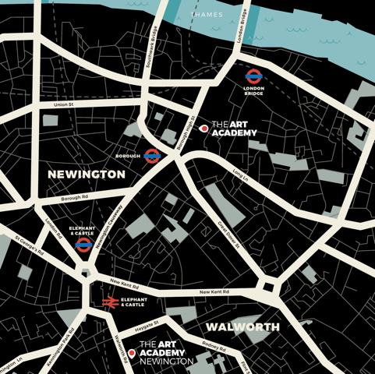

Who can I contact for further information?
General information and advice on courses at Art Academy London is available from the main office, open Monday to Friday 09:00 – 17:00 during term time.
Tel: +44 (0) 20 7407 6969 or email our Reception, Imogen Patel: imogen@artacademy.org.uk

Location
The Art Academy is conveniently located minutes away from London Bridge (Northern and Jubilee lines, National Rail services) and Borough (Northern line) underground stations - follow signs for Borough High Street to exit. Please click here for a map.

Just moments walk from the Thames, Art Academy London is also ideally located for access to:

White Cube
Tate Modern
Jerwood Gallery

If you would like to make the most of the area a member of the team will be happy to advise you on areas of interest locally.

Refreshments & Facilities

All students have access to the common room located in the Barn, on the ground floor of the Mermaid Court building. Here you will have use of a fridge, kettle, microwave and eating area.

There is a wealth of supermarkets, shops and cafes in the area as well as the world-famous Borough Food Market, five minutes walk away.

Disabled Access
We make every effort to accommodate students’ access requirements, but if you have mobility issues, please speak to a member of the Academy team before your course starts.

Further Details

- You will need to have paid in full for your class before the first session of your class, your place is not guaranteed until we have received payment.

- If you purchased a materials pack online this will be given to you on the first session of your course upon your arrival.

- Ensure that you wear old clothing, as you may get messy!

- All artwork at the Academy MUST be taken home at the end of the course.

- Please ensure that your mobile phone is switched off, or is on silent, during the class.

- Please read the Health and Safety Guidelines carefully, provided at the beginning of your course.

- If you wish to join any class for the next term please contact the office to re-book. Classes are becoming increasingly popular, so please book early in order to guarantee your place.

- If you have any further queries let us know and we will do our best to resolve them. Thank you for your cooperation and we look forward to seeing you.

